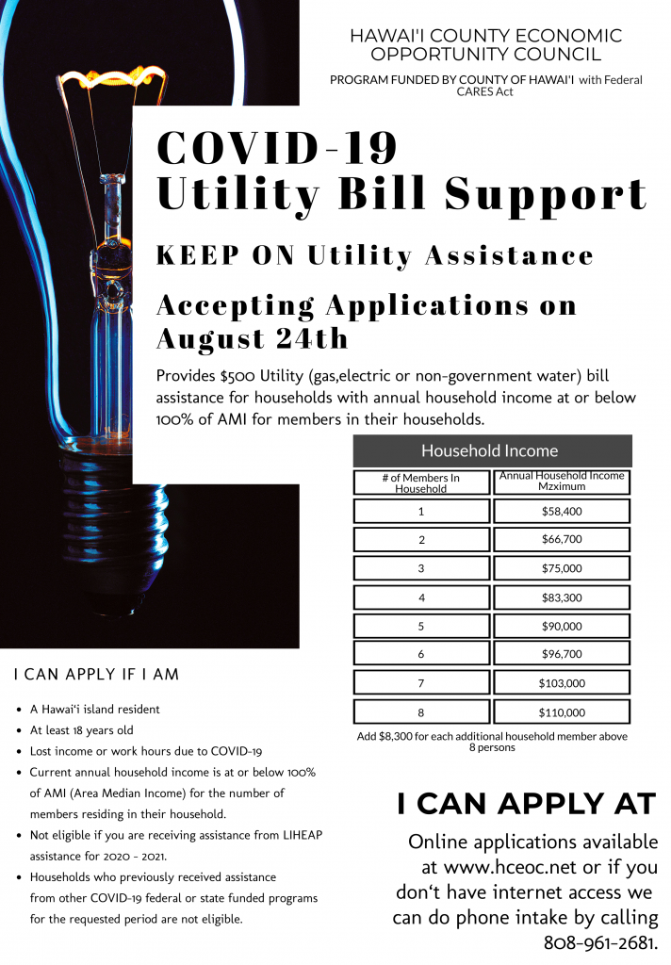

**Required documents for application**

* Government-issued identification
* Income verification documents for all household members
* Utility Statement (with the address of services)
* Lease/Rental Agreement or Mortgage document
* Proof of hardship (May include, but not limited to, pay stubs documenting pre-COVID-19 income, unemployment approval letter, layoff letter)

CARES Utility Assistances